March 10, 2020

Comrades:

The VFW National 2020 Spring Legislative Conference was held in Washington D.C. March 1-5, 2020. During this time, representatives from all 50 States gathered to meet with their elected Congressional Officials on Capitol Hill to inform them of, and seek their support for the VFW's Legislative Priorities. Those in attendance representing the Department of Idaho VFW and their Auxiliary were Bob Jones, Department Legislative Chairman and his wife Carmelita, Past Department President; Bill Heyob, State Commander and his wife, Nancy; Rick Johnson, National Council Representative; and Bob Tettleton, Aide to the Commander and his wife, Shalimar. Please see photos below of those in attendance.

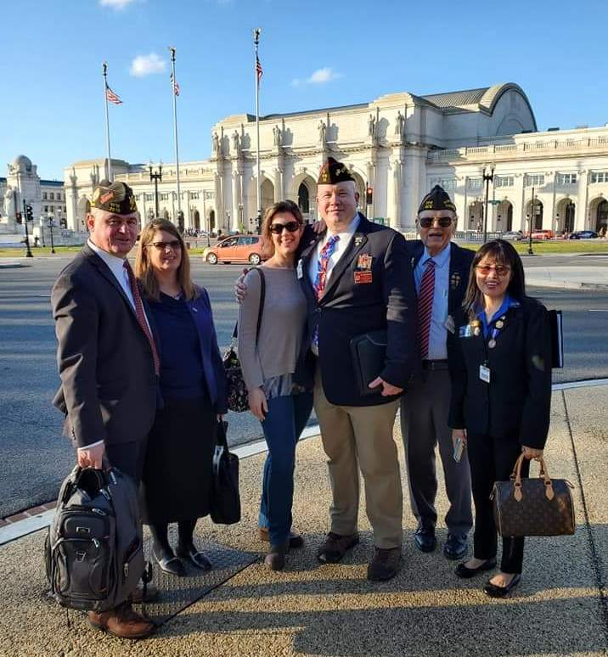

VFW ID Delegation in Washington, DC

The Legislative Conference was extremely successful. Our delegation personally met with Senators Crapo and Risch. We also got pictures taken with Congressman Fulcher. However, he had to leave for a vote on the floor. We did get to sit and speak to both Congressmen Fulcher and Simpson's Legislative staffers. Please see the attached on the Legislative Issues discussed.

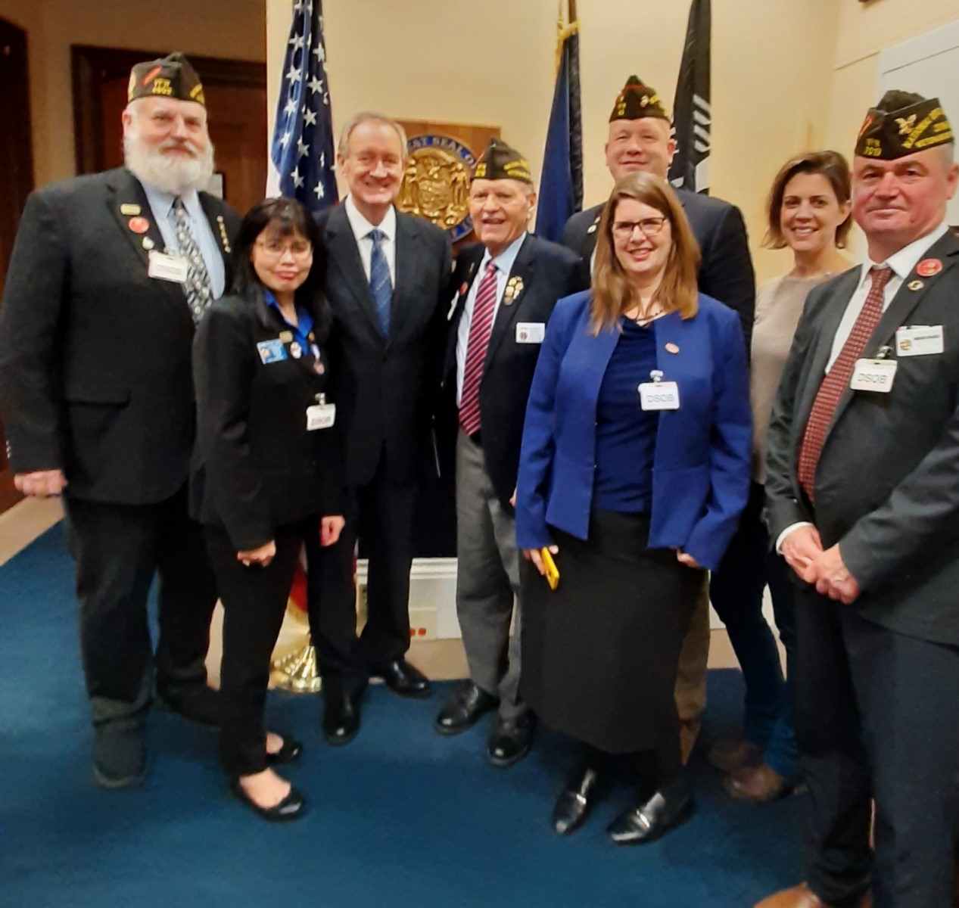

VFW ID Delegation with U.S. Senator Mike Crapo

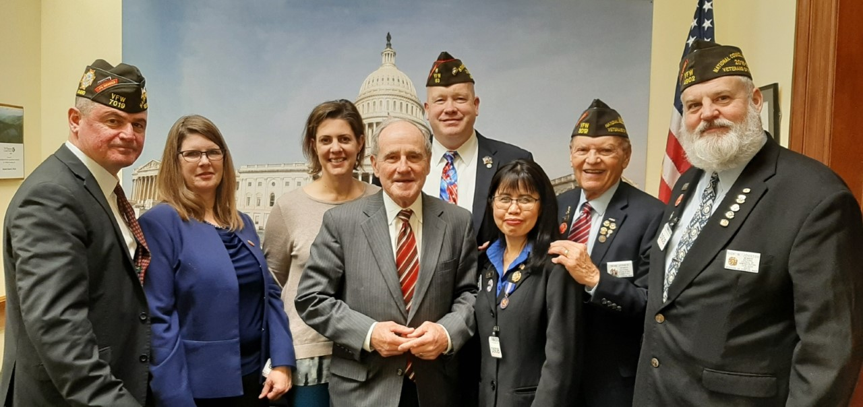

VFW ID Delegation with U.S. Senator Jim Risch

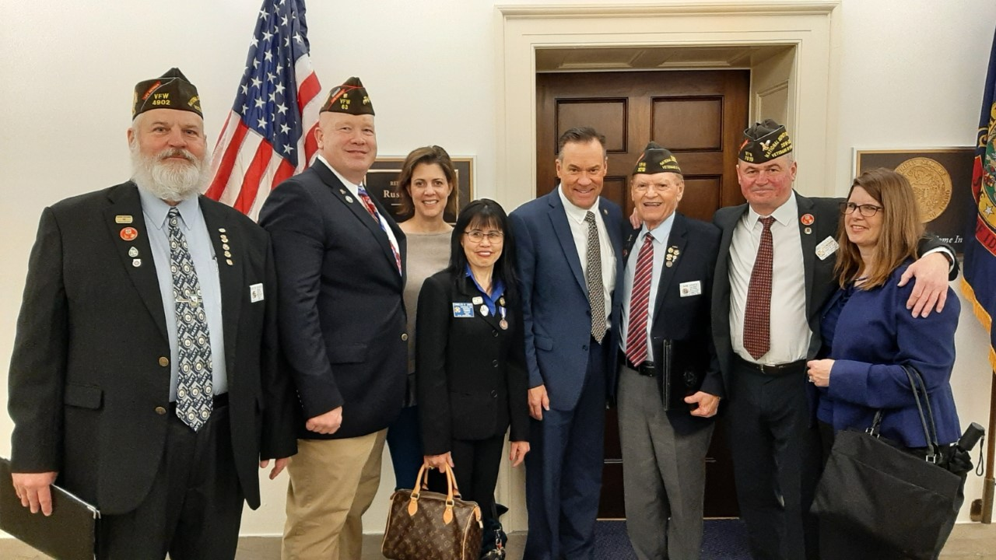

VFW ID Delegation with U.S. Representative Russ Fulcher

Our delegation also attended our National VFW Commander-in-Chief William "Doc" Schmitz's presentation to a special joint hearing of the Senate and House Committees on Veterans Affairs. Please click on the following link to watch the hearing:

https://www.vfw.org/media-and-events/2020-vfw-legislative-conference

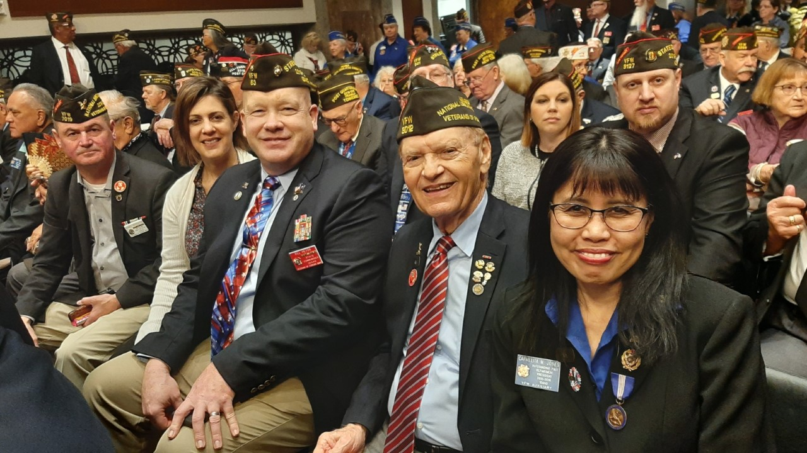

VFW ID Delegation at the VFW CIC Doc Schmitz Testimony Hearing at Capitol Hill

In addition, we enjoyed a very special occasion-- We watched Lilianne Anderson, our Department of Idaho Voice of Democracy winner being escorted down the Parade of Winners by our State Commander Bill Heyob and his wife, Nancy. Lilianne was awarded with a $1,500 university scholarship and a Dell laptop computer. It was a very proud moment for the Department of Idaho. Please see photo below.

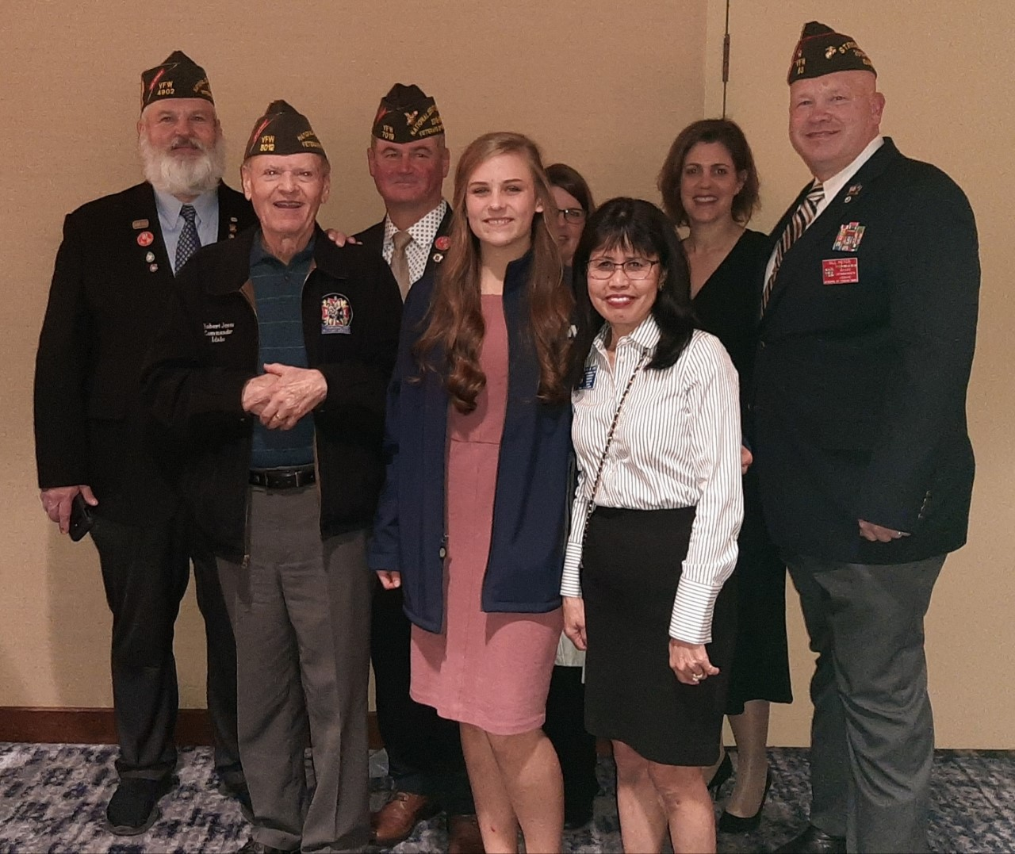

VFW ID Delegation with ID VOD Winner Liliane Anderson

Please pass this email on to all of your members.

Best wishes,

Bob Jones
Legislative Chairman
All-American Commander
Department of Idaho
Veterans of Foreign Wars

