2023 Voice of Democracy Department of Idaho Winners
Theme “Why is the Veteran Important?”
1st Place Julia Grimaldo – Sponsored by Harrold Kinne Post 3296, Orofino
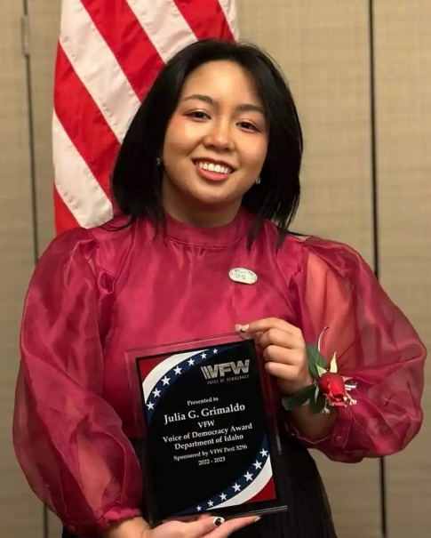
2nd Place Brodie Merrell 3rd Place Sydney Lenz
Sponsored by Glenns Ferry Post 3646 Sponsored by SGT Devin Daniels
Post 7019, Kuna
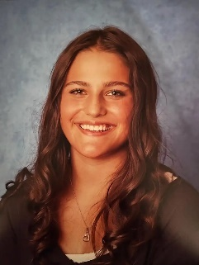

2023 Patriot’s Pen Department of Idaho Winners
Theme “My Pledge to Our Veterans”
1St Place Lynnlee Merrell – Sponsored by Glenns Ferry Post 3646
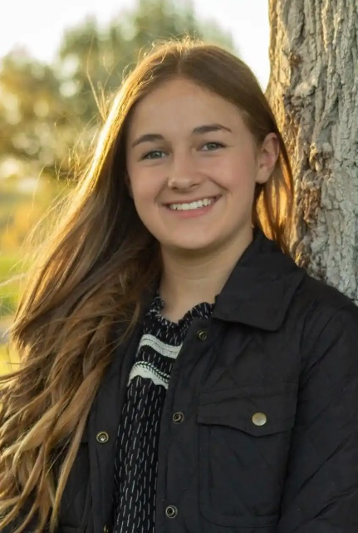
2nd Place Isaac Hall 3rd Place Britton Wheeler
Sponsored by Mud Lake Post 8893 Sponsored by SGT Devin Daniels
Post 7019, Kuna
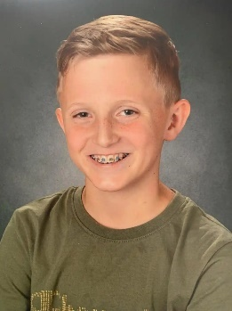

2023 Teacher of the Year Winners for K-5, 6-8, and 9-12

Teacher Grades K-5 –Kelly Garey – Sponsored by Lt. L.D. Patterson Post
3886, Caldwell
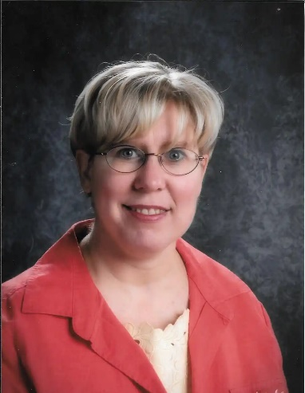
Teacher Grades 6-8 – Duke Marchand – Sponsored by Sourdough Post 10043,
Lewiston
Teacher Grades 9-12 – Karen Brescia – Sponsored by Mountain Home Post 5423

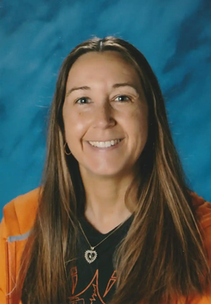
2023 Department of Idaho Public Servant Awards

Dispatcher – Mark Nugent EMT – David Chenault
Lewiston Police Department City of Lewiston
Sponsored by Post 10043 Sponsored by Post 10043
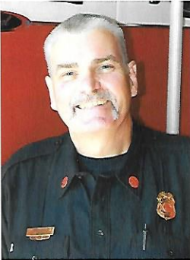

Fire Fighter – Travis Myklebust Law Enforcement – Stanley J Denham
City of Lewiston ID County Sheriff’s Office
Sponsored by Post 10043 Sponsored by Post 3520
